TURTON PRIMARY CARE NETWORK EXTENDED HOURS

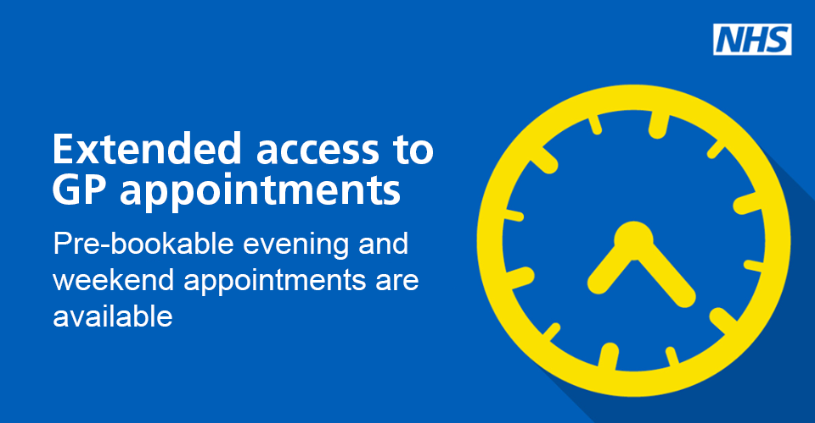

We are offering extended hours appointments from Saturday 01st October 2022.

These appointments will be offered by your GP Surgery.

Locations:
Harwood
Harwood Medical Centre
Hough Fold Way
Bolton
BL2 3HQ
(Tuesdays and Saturdays)
18:30pm – 20:00pm Tuesday
09:00am – 17:00pm Saturday

Egerton & Dunscar Health Centre
Darwen Road
Bromley Cross
Bolton
BL7 9RG
(Monday and Wednesdays)
18:30pm – 20:00pm

Oaks Family Practice
Crompton Health Centre
501 Crompton Way
Bolton
BL1 8UP
(Thursdays and Fridays)
18:30pm – 20:00pm

Extended Hours Contract: 01204 462050

